Qualitative data
# Source: AI Source: Provided by: [Data Path: Persons Table -> ID Column: 1, Name_En Column: Motasem Essam] -> From: [Chatgpt (GPT‑5 Mini)] on [12/10/2025]
Qualitative data is data that describes qualities or characteristics rather than numbers. It tells us “what kind” or “which type” something is.

Definition:
# Source: AI Source: Provided by: [Data Path: Persons Table -> ID Column: 1, Name_En Column: Motasem Essam] -> From: [Chatgpt (GPT‑5 Mini)] on [12/10/2025]
Qualitative data = descriptive data that cannot be measured with numbers, but can be observed or categorized.

Key Features:
# Source: AI Source: Provided by: [Data Path: Persons Table -> ID Column: 1, Name_En Column: Motasem Essam] -> From: [Chatgpt (GPT‑5 Mini)] on [12/10/2025]
- Non-numerical.
- Usually expressed as words, labels, or categories.
- Often used to describe attributes, opinions, or characteristics.

Examples of Qualitative Data:
# Source: AI Source: Provided by: [Data Path: Persons Table -> ID Column: 1, Name_En Column: Motasem Essam] -> From: [Chatgpt (GPT‑5 Mini)] on [12/10/2025]
- Eye color → Blue, Brown, Green
- Gender → Male, Female
- Hair type → Curly, Straight, Wavy
- Opinion on a product → Good, Average, Poor
- Blood type → A, B, AB, O

Contrast with Quantitative Data:
# Source: AI Source: Provided by: [Data Path: Persons Table -> ID Column: 1, Name_En Column: Motasem Essam] -> From: [Chatgpt (GPT‑5 Mini)] on [12/10/2025]
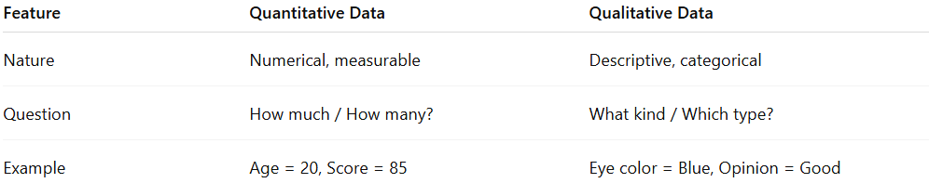
Feature | Quantitative Data | Qualitative Data
Nature | Numerical, measurable | Descriptive, categorical
Question | How much / How many? | What kind / Which type?
Example | Age = 20, Score = 85 | Eye color = Blue, Opinion = Good

✅ Summary:
# Source: AI Source: Provided by: [Data Path: Persons Table -> ID Column: 1, Name_En Column: Motasem Essam] -> From: [Chatgpt (GPT‑5 Mini)] on [12/10/2025]
- Quantitative: Numbers → measurable
- Qualitative: Words → descriptive

